
Schedule A
Financial Assistance Table*

To apply for Financial Assistance, the patient (or family) must complete Hebrew Home & Hospital’s Patient Financial Assistance Application, including requested documentation.

Federal Poverty Guidelines effective 2024 are listed below:

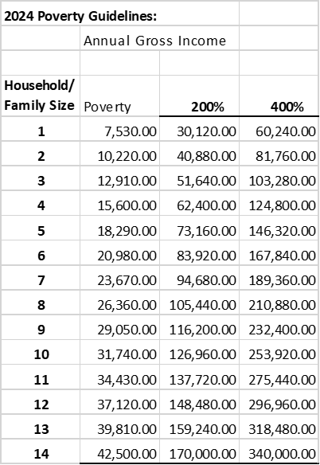

*This Table will be adjusted in accordance with annually released changes to the Federal Poverty Guidelines. The current FPG at the time service is provided will be used in the determination of eligibility under the Financial Assistance Policy.

Schedule B

Providers Not Covered by Financial Assistance Policy

The following contracted psychiatrists are NOT covered by the Financial Assistance Policy:

Connecticut Medical Health Specialists, Inc.

